**Machine Learning - Based Web Application Documentation**

1[Link Placeholder] Introduction 🚀

1[Link Placeholder]1 Overview

Welcome to our machine learning-powered web application, designed to supercharge your data analysis and data science projects[Link Placeholder] Our mission is to simplify complex data science tasks and empower users to explore, analyse, and model their data effortlessly[Link Placeholder] 💡

1[Link Placeholder]2 Objectives and Goals

Our primary objectives are to eliminate coding hassles and help users:

* Automate redundant data science tasks[Link Placeholder] 🤖
* Effortlessly analyse and visualize data[Link Placeholder] 📊 📈
* Simplify data preprocessing[Link Placeholder] 🧹
* Train machine learning models without coding[Link Placeholder] 🤖📚
* Save and interpret their models with ease[Link Placeholder] 💾

2[Link Placeholder] Accessing the Application 🌐

2[Link Placeholder]1 Web-App Link

You can access our application through the following link: [Link Placeholder]📌

(Works best in **Laptop/Desktop** or in **Mobile phones** with **Horizontal screen )**

2[Link Placeholder]2 YouTube Tutorial

For a detailed step-by-step guide, check out our YouTube tutorial: [Link Placeholder] 🎥

2[Link Placeholder]3 Guest Access

We offer a seamless experience where you can continue as a guest without the need for account creation[Link Placeholder] 🙌

3[Link Placeholder] Application Workflow 🔄

3[Link Placeholder]1 Data Upload

To embark on your data analysis journey:

* Upload Your Data: Simply upload your dataset in CSV format[Link Placeholder] It's quick and easy! 📁

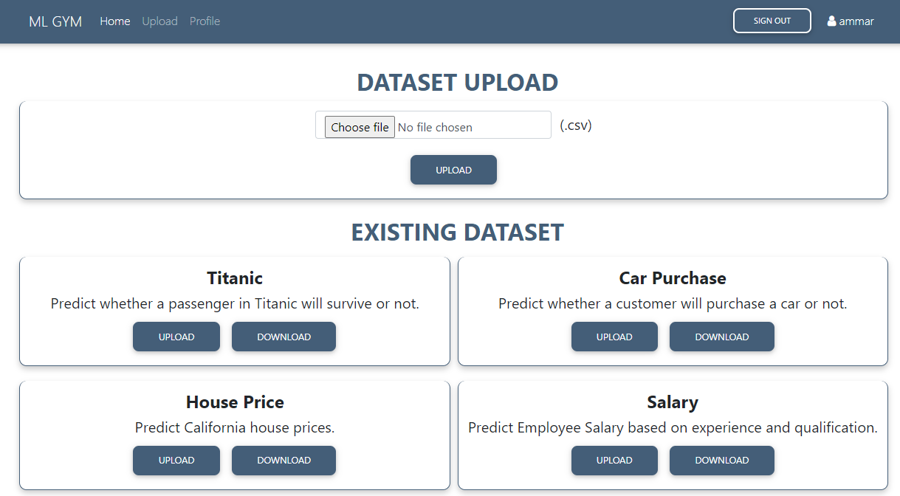

3[Link Placeholder]2 Explore Your Data

Our application swiftly analyses your dataset and provides:

* Insightful Visualizations: Explore your data with ease through textual, tabular, and graphical visualizations[Link Placeholder] 📈📊📋

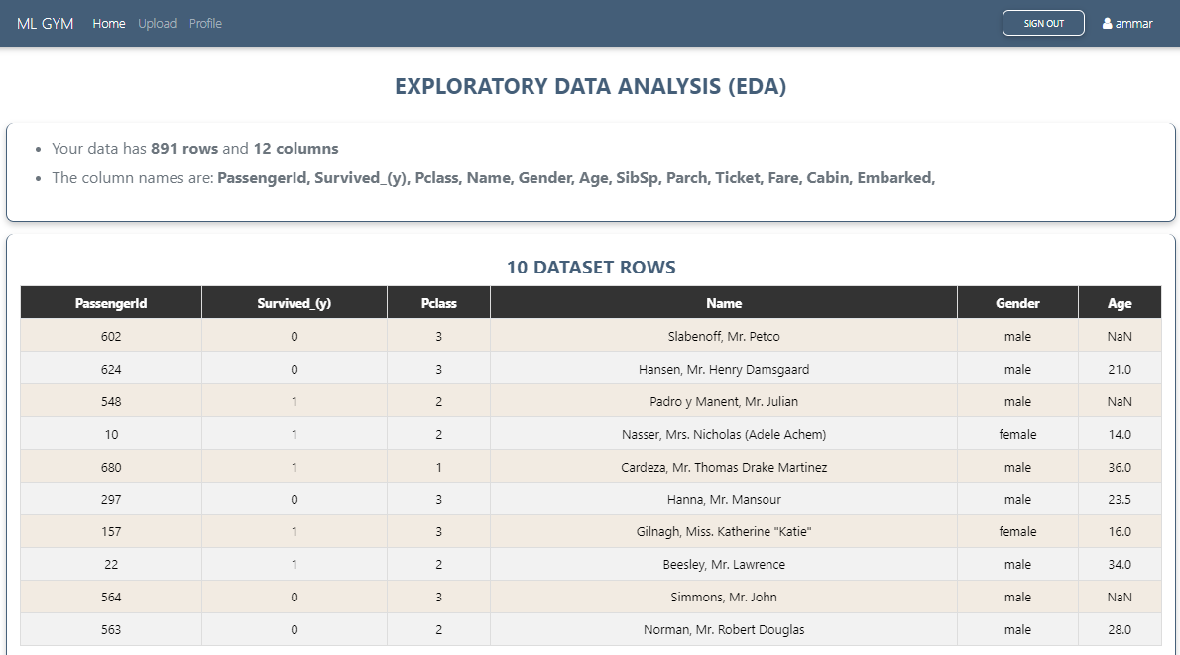

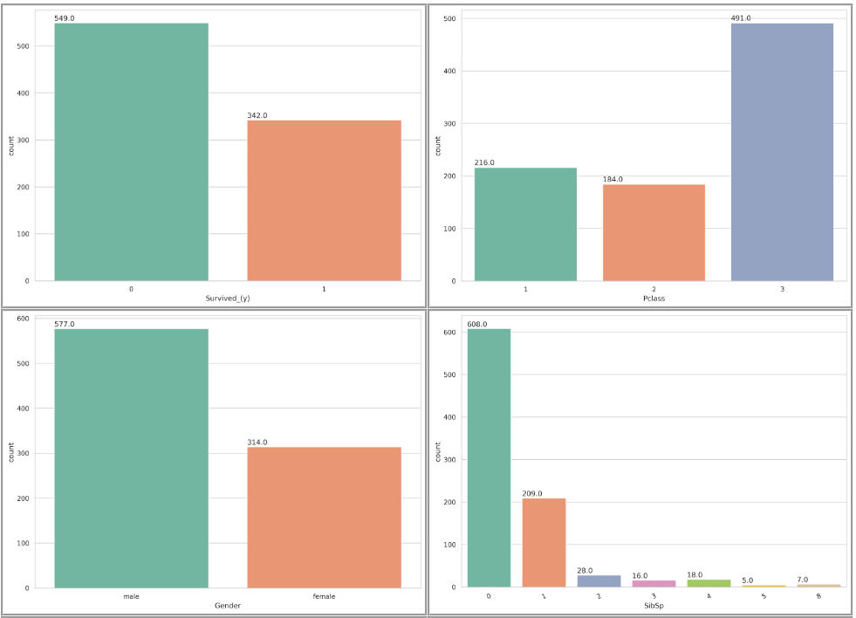

3[Link Placeholder]3 Effortless Data Preprocessing 🧹

* Handle Missing Values: Use radio buttons to handle missing data effortlessly[Link Placeholder] 📻
* Train-Test Split: Set your train-test split ratio with an intuitive slider[Link Placeholder] 🔄
* Select Dependent Variable: Easily choose the dependent variable from a dropdown menu[Link Placeholder]

3[Link Placeholder]4 Train Your Model 🤖

With just a few clicks, you can create your machine learning models using various algorithms:

* No Coding Required: Select a model from the dropdown menu containing several ML Algorithms and click to train[Link Placeholder] 🧰📚

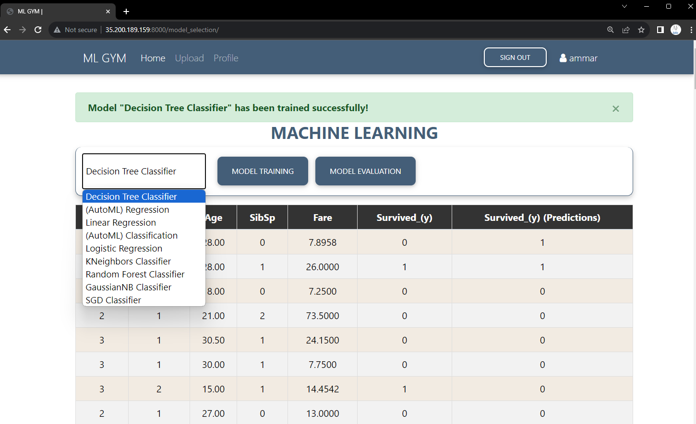

* Model Evaluation: See immediate model evaluation to assess its performance[Link Placeholder] 📈📊

3[Link Placeholder]5 Save Your Model 💾

Once you've perfected your model:

* Effortless Saving: Save it for future use and interpretation[Link Placeholder]

* Model Testing: Access your saved models in your profile for testing on custom inputs[Link Placeholder] 📦🔐

3[Link Placeholder]6 Interpret Your Results 📈

Gain valuable insights into your model's predictions and understand how it makes decisions:

* In-App Analysis: Dive into your results and interpret them right within the application[Link Placeholder] 🧐🔍

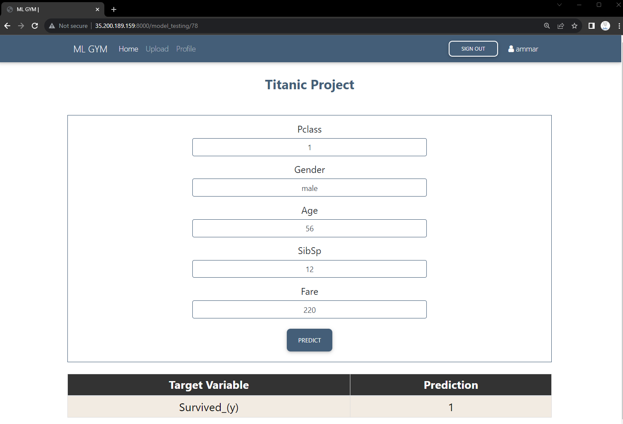

3[Link Placeholder]7 Future Improvements 🚀🌟

Here's what's coming up next in our exciting roadmap:

* Graphical Analysis 📊👀: Users will soon be able to craft custom graphs between various dataset columns for in-depth insights at the click of a button[Link Placeholder] 📈🖱️
* Tabular Analysis 📑🔍: Get ready to interact with your dataset using conversational queries that will return neatly organized tables filled with your data[Link Placeholder] 🗣️➡️🏓
* Custom Preprocessing ✂️🔄: We're introducing tools to help you easily identify and remove outliers from your dataset's columns, ensuring cleaner data for analysis[Link Placeholder] 🧹📊
* ML Parameters Selection ⚙️🤖: Tinker to your heart's content with machine learning model parameters for a tailored and optimized predictive model[Link Placeholder] 🔧🧠
* Forecasting 📆🔮: Extend your predictive prowess beyond Regression and Classification models; soon, you'll be able to train and test Forecasting models for a glimpse into the future trends[Link Placeholder] 🌐💫